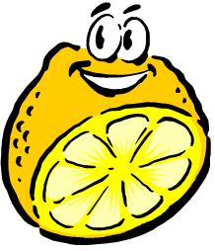
Acids and Bases
Acids
Properties of Acids
- ______________________ tasting
- ______________________
- Water ______________________
- Good Conductor of ______________________
When mixed in with water release ________________atoms.
When combined with ________________, acids produce ________________gas
Example: Zn + HCl → ZnCl + H₂
When combined with ________________, they produce ___________________gas
Example: HCl + CaCO₃ → CO₂ + H₂O + CaCl
Bases
Properties of Bases
- ______________________ tasting
- ______________________ Water Soluble
- Good Conductors of ______________________
When in water release ______________________
Bases react with ______________________ (like those in your skin and eyes)

Is it an acid or base?
Usually acid starts with ______________________
______________________: hydrochloric acid
______________________: sulphuric acid
______________________: nitric acid
Sometimes bases will have ______________________
______________________: Sodium hydroxide
______________________: Potassium Hydroxide
______________________: Ammonium hydroxide
pH scale
pH scale: a scale that represents the amount of ______________________ ions
The pH scale ranges from ______________________
Sketch the pH scale below:

Neutralization
Neutralization: an _______________ and ________________ react to form a ____________ and a _______________________.
A special case of _________________ _________________.
HCl + NaOH -> H₂O + NaCl

